Campus Room Requests & Event Reservations

- Log-in to Campus Room Requests & Event Reservations using your OLLU username and password

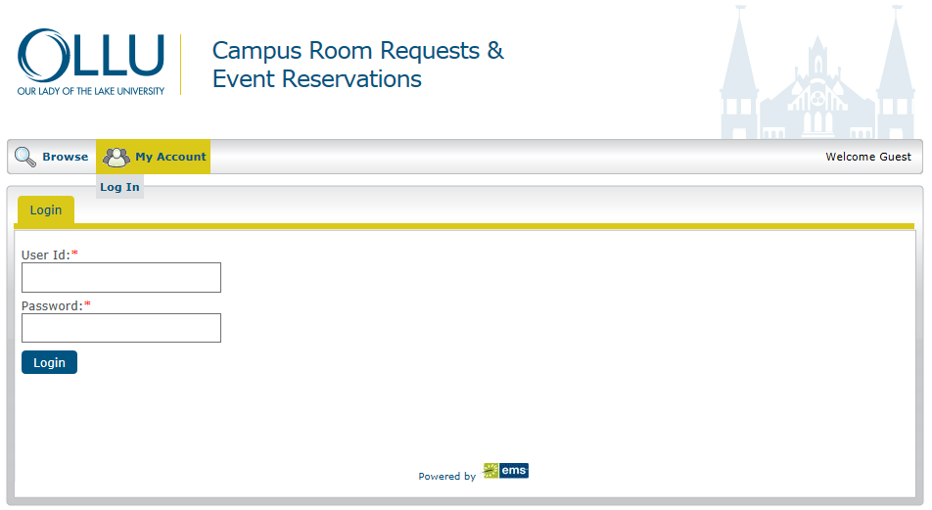
Click on “My Account,” then click on “Log In.” This will prompt you to enter your OLLU Username and Password. Then click “Login.”

- Once you Login to Campus Room Requests & Event Reservations the following tabs appear:

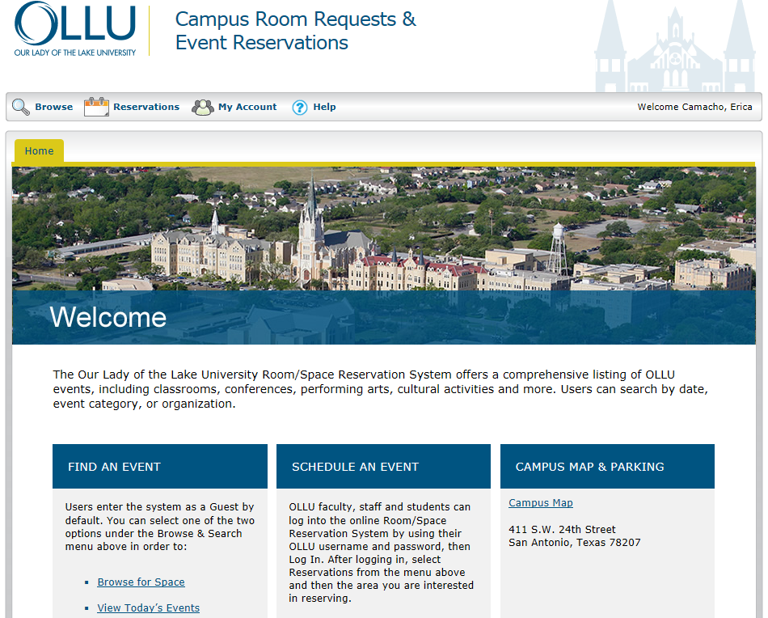

- The Browse tab allows you to browse events, facilities, or spaces and locate a group
- The Reservations tab allows you to do the following
  - Request a Classroom
  - Request a Venue (e.g., PWSR or Providence Hall, Blue Room)
  - Request a Conference Room
  - Request Thiry Auditorium or 24th Street Theater
  - Request Equipment and/or Furniture ONLY
  - View My Requests (this allows you to view any of your current or previous requests).
- The My Account tab allows you to Log Out
- The Help tap –currently this tab brings up the Knowledge Base website and prompts for username and password log-in and also provides a “Virtual EMS User’s Manual
- How to Reserve Space in Campus Room Requests & Event Reservations
  - Select the Type of Reservation you wish to make:
    - Classroom Request
    - Venue Requests (e.g., PWSR, Blue Room)
    - Thiry Auditorium/24th Street Theater
The example below demonstrates how to submit a Classroom Request:
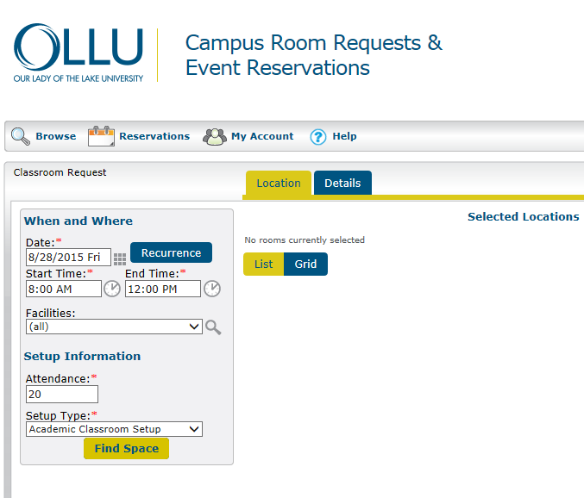

  - “When and Where”:
Note: Fields with (*) are required

    - Select the date(s) of your event (if it is a reoccurring event, select the “Recurrence” button. This will allow you to select multiple dates for your event).
    - Next, enter the Start and End time of your event
    - Then select the drop down menu under “Facilities” to select a particular building; otherwise, you can search “All.”
    - Enter the anticipated attendance for your event
    - Then select a “Setup Type” (note: with classrooms there are only two setup type options: Academic Classroom or Computer Lab)
    - Once you have entered all of the information select “Find Space.”
There are two different ways in which you can view space availability:
- List—this will give you a listing of space available with location and seating capacity information.
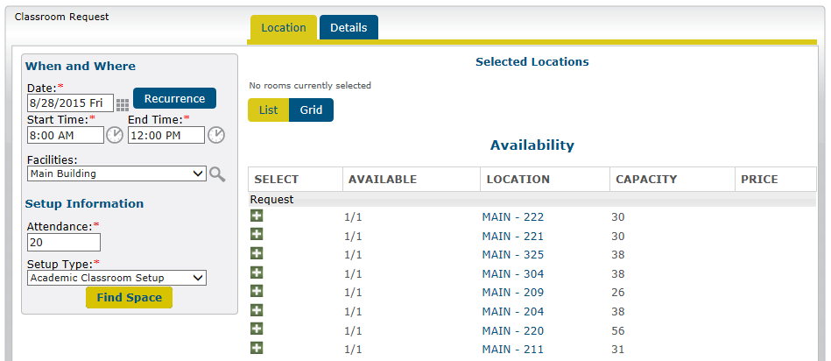

- Grid— this will give you a listing of space available with location, seating capacity and give you a visual of the “start and end time” of your request. View will also show you space that is not available.
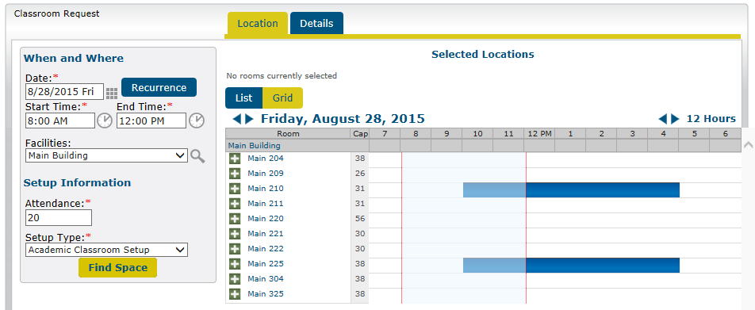
- Adding the space to your reservation request:
  - Once you determine which space will accommodate your event, select the space by clicking on the icon.
Note: the space selected will be removed from the list and moved up to the “Selected Locations” area of your screen (see below):
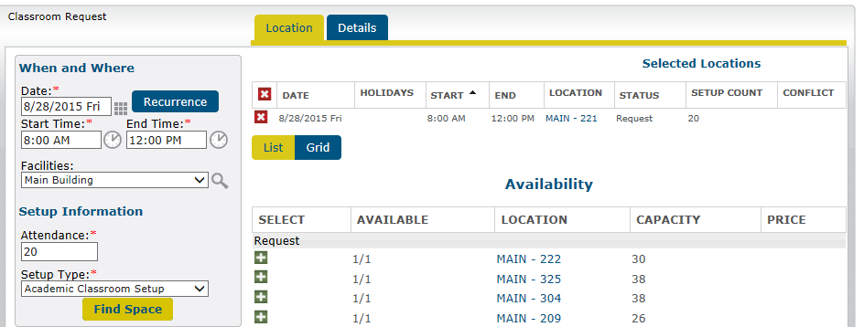

  - After you have selected the space you would like to reserve, read and select the that states, “I have read and agree to the terms and conditions”.
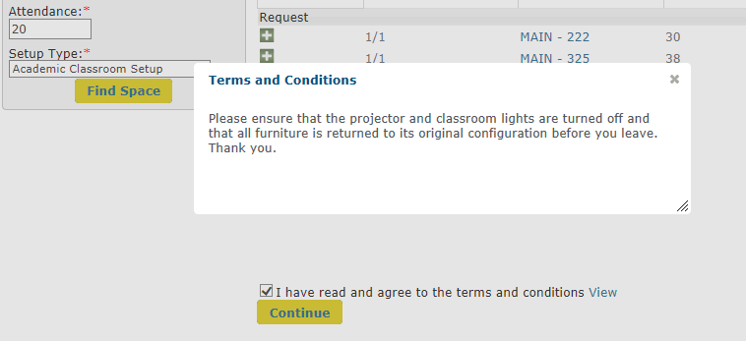
  - Select “Continue.”

- Event Details:
  - Event Name: Name of the Event
  - Event Type: What type of event is it? (e.g., meeting)
  - Customer: Are you faculty, staff or a student?
  - Customer Name: Select your name here
  - Customer Phone Number: If you are a faculty or staff member, your phone information will auto populate. If you are a student you must enter your contact information.
  - Customer Email: If you are a faculty or staff member, your phone information will auto populate. If you are a student you must enter your contact information.

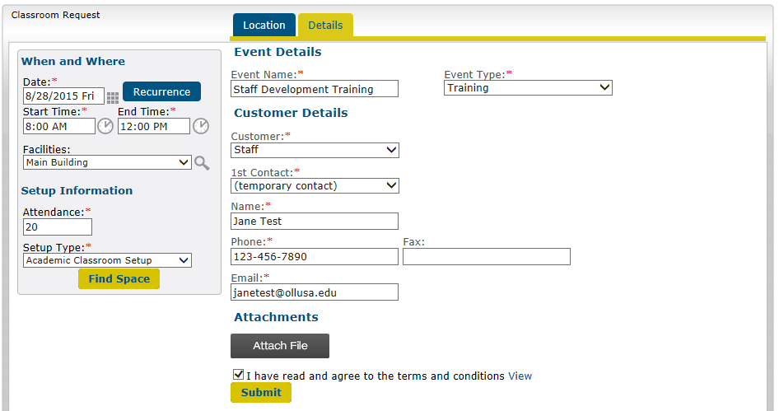

Once you have entered all of your event information, click “Submit.”

- Reservation Details:
  - Current tab—This will allow you to make changes to any current reservation, add a reservation or cancel a reservation.
  - Historical tab—This will allow you to see the details on the history of reservations you have submitted.
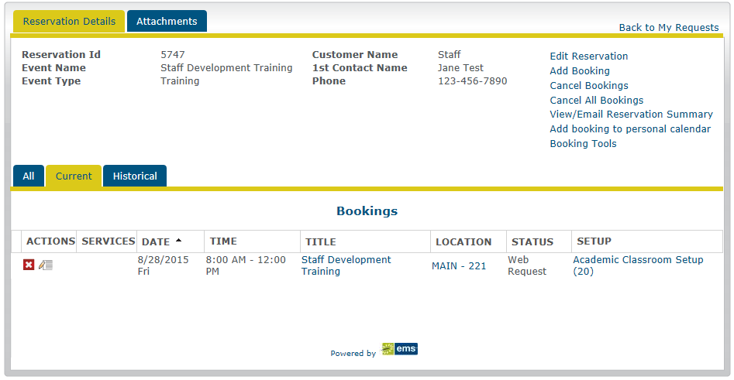

Once your request is submitted, there will be a notification sent to the staff member that reserves the space, at that time the request will be reviewed.

Confirmation:
A confirmation email with the event details similar to the example below will be provided to you via your OLLU email address.

