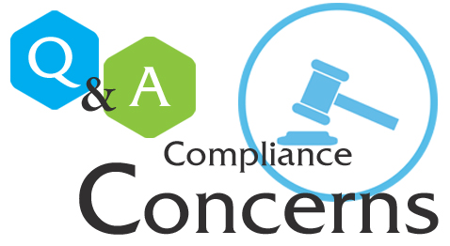

Quarterly Compliance Q & A Hour
Wednesday, October 26, 2016
2:00pm to 3:00pm
Moye 305*
What are all those acronyms
FERPA, HIPAA, Title IX, Etc.
Have a question, stop by for an afternoon snack and ask away!
Suzanne Patrick, Compliance Officer
*If you are in Houston, La Feria you can call 210-431-6552 with your questions.

